COMMON ERRORS IN KRONOS

TIP: Do a CTRL + Click on the topic to link to the error details

Employee Error Details 2
Entering work hours before they have actually been worked. 2
Typing BAS on the work hours in Kronos. 2
Deleting, editing or adding holiday leave time. 2
Incorrectly recording overtime hours. 2
Incorrectly electing overtime pay. 3
Not following the 40-hour workweek. 3
Using leave to exceed 40 hours in a workweek. 3
Incorrectly reporting leave time 4
Incorrectly recording on-call pay 4
Entering hours in the wrong pay period 5
Not approving the timecard by the deadline 5
Supervisor Error Details 6
Not reviewing each individual timecard. 6
Not checking to see if each full-time employee has 40 hours each workweek. 6
Not reviewing the overtime (OVT and CTO pay codes) to ensure it is correct. 6
Approving the employee’s timecard before they have approved it. 6
Not reviewing on-call hours to ensure they are correct and that the employee hasn’t exceeded 24 hours in a day except on the holidays. 6
Not verifying the leave time reported in Kronos against the approved leave slips or RFL reports. 6
Allowing non-exempt employees to use leave to exceed 40 hours in a workweek. 6
Mistakenly approving time outside of the pay period 6
Giving out Kronos user ID’s and PINs 7
Not ensuring employees are recording time to the correct grant or project. 7
Not approving employee timecards by the deadline. 7

Employee Error Details

Entering work hours before they have actually been worked
  - Employees are not allowed to record their work time until they have actually worked it. Some employees think it is okay to record the time as long as they don’t approve it until after it is worked. That is incorrect. Federal guidelines don’t allow employees to even record the time until it has actually been worked. Not following this guideline could jeopardize federal funding.
  - Work hours entered in advance may be deleted by HR.
  - Leave time such as vacation or sick leave CAN be entered and approved in advance.

Typing BAS on the work hours in Kronos
  - Employees should leave the pay code box blank when recording work time.
  - Incorrect: 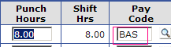
  - Correct: 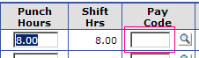

Deleting, editing or adding holiday leave time
  - The HOL and HOL-E pay codes are automatically entered by Human Resources. Employees and supervisors should not be adding, editing or deleting these records.

Incorrectly recording overtime hours
  - Non-exempt employees who have approval to work overtime should record their total hours worked each day without using any overtime pay codes such as CTO or OVT.
  - CTO and OVT will be automatically generated once the employee records more than 40 hours of work in a week.
  - Employees should never type CTO or OVT on their timecard.
  - Incorrect: 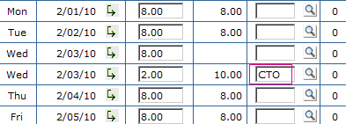
  - Correct: 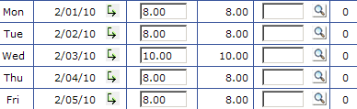 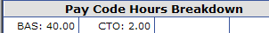 Kronos automatically calculated the 2 hours of overtime as CTO (comp time overtime).

Incorrectly electing overtime pay
  - Employees must follow the proper procedure to request pay for overtime hours worked. That procedure is outlined here: http://www.dhhs.ne.gov/kronos/docs/1.5.pps

Not following the 40-hour workweek
  - The workweek runs from Saturday at 12 a.m. through Friday at 11:59 p.m.
  - Non-exempt employees must record 40 hours each week. Non-exempt employees cannot record 41 hours one week and 39 hours the other week. This would lead to 1 hour of overtime the first week and a shortage of hours in the second week.
  - Exempt employees are allowed to do some flexing of hours with supervisory approval but should still make sure they report 40 hours each week to avoid reduced pay.

Using leave to exceed 40 hours in a workweek
  - Employees may not use leave to receive more than 40 hours of pay in a workweek. For example, if a non-exempt employee records 34 hours of work and 8 hours of vacation, they would be incorrectly reporting 42 hours for the week. Instead, the vacation must be reduced to 6 hours to equal an even 40 hours for the week.
  - Incorrect: 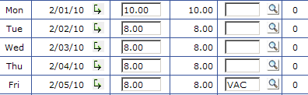
  - Correct: 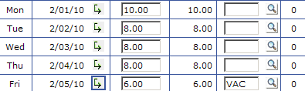

Incorrectly reporting leave time
  - Leave time must be reported using the Pay Code field in Kronos. Employees may use the comments feature to provide additional information about the leave usage but cannot use the comments instead of the pay code field to report leave time.
  - Incorrect: 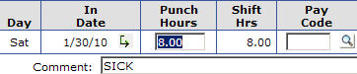
  - Correct: 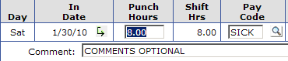
  - Employees also need to ensure they are using the correct pay code. Please refer to the pay code listing for details. Employees should never use system-generated pay codes or Human Resources-selected pay codes without permission from Human Resources.

Incorrectly recording on-call pay
  - Employees eligible for on-call pay must report their hours using the OCL pay code. Some employees are mistakenly using OCP or BAS to record their on-call time.
  - Employees should not have more than 24 hours of pay on any day except the holiday.
  - On the holiday, employees may have 24 hours of OCL and 8 hours of holiday pay if they did not work at all on that day.

Entering hours in the wrong pay period
  - Please watch the dates showing on your timecard before proceeding to enter time. When payroll is processing, your hours for the pay period that just ended will be sent to NIS and will go into history in Kronos. However, the dates will not roll forward to the next pay period until all other areas have finished their process. That means you will need to use the pay period drop down to pick the next pay period in order to record your hours on the correct dates.
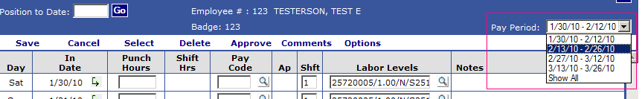

Not approving the timecard by the deadline
  - Employees need to ensure that each time record has a 1 showing in the AP column.
  - Approvals need to be done by the end of the first business day after the end of the pay period.

Supervisor Error Details

Not reviewing each individual timecard
  - The Hours Summary screen provides a snapshot of the employee’s timecard. However, if there are leave, overtime or on-call hours, you must still review the actual timecard for each employee to verify leave and catch errors with overtime or on-call pay.

Not checking to see if each full-time employee has 40 hours each workweek
  - Please review each Saturday through Friday workweek to ensure 40 hours are recorded in each week.

Not reviewing the overtime (OVT and CTO pay codes) to ensure it is correct
  - If you see OVT or CTO pay codes on an employee’s timecard, you should be reviewing the hours closely to ensure these were approved overtime hours.

Approving the employee’s timecard before they have approved it
  - Supervisors should not approve the employee timecard until all records have an approval level of 1 on them UNLESS the employee is unavailable to approve it themselves.

Not reviewing on-call hours to ensure they are correct and that the employee hasn’t exceeded 24 hours in a day except on the holidays
  - Supervisors should review days where the employee worked and had on-call pay to ensure the total hours for that day do not exceed 24.
  - On a holiday, employees are entitled to their 8 hours of holiday pay in addition to 24 hours of on-call pay if they did not work on that day.

Not verifying the leave time reported in Kronos against the approved leave slips or RFL reports
  - Supervisors should review all leave usage reported in Kronos to ensure it matches what the employee was approved to use.

Allowing non-exempt employees to use leave to exceed 40 hours in a workweek
  - Supervisors must instruct employees to reduce leave usage to avoid going over 40 hours in a workweek.

Mistakenly approving time outside of the pay period
  - Supervisors should ensure they are not approving future timecards that haven’t yet been approved by the employee.

Giving out Kronos user ID’s and PINs
  - Supervisors are not allowed to give their ID and PIN to anyone else. If another supervisor is covering for you during an absence, HR should be notified to give that supervisor the necessary access under their own ID and PIN to approve time.

Not ensuring employees are recording time to the correct grant or project
  - Supervisors who have employees recording time to various grants or projects should be reviewing the codes used to ensure employees are accurately reflecting their time spent on each grant or project.

Not approving employee timecards by the deadline
  - Supervisors need to ensure that all employee timecards have a level 2 supervisor approval by the deadline.
  - The deadline is 10 a.m. in the supervisor’s local time zone on the second business day following the end of the pay period. For example, if the supervisor is in Gering, they must finish approvals by 10 a.m. Mountain Time. If the supervisor is in Lincoln, they must finish approvals by 10 a.m. Central Time.

